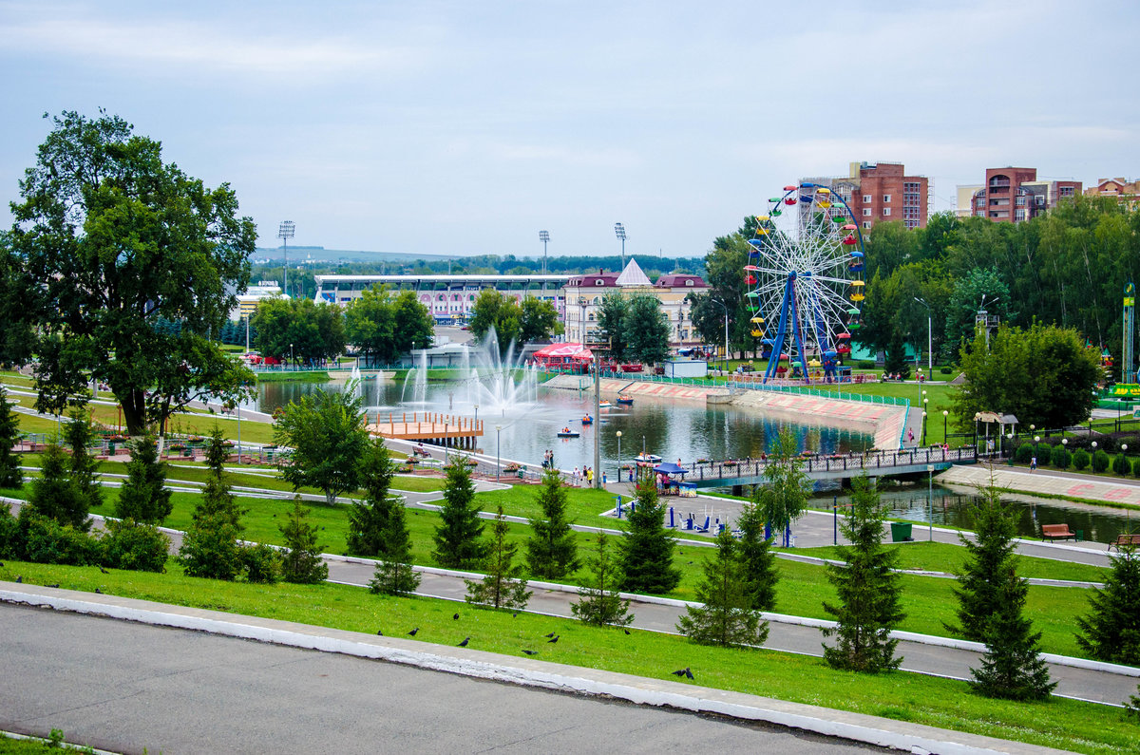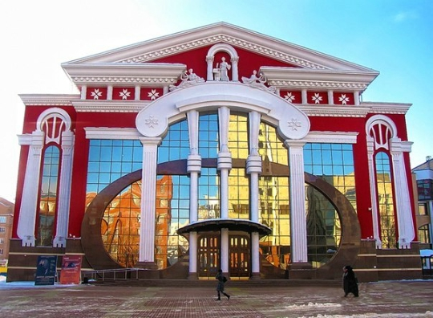

My Mordovia

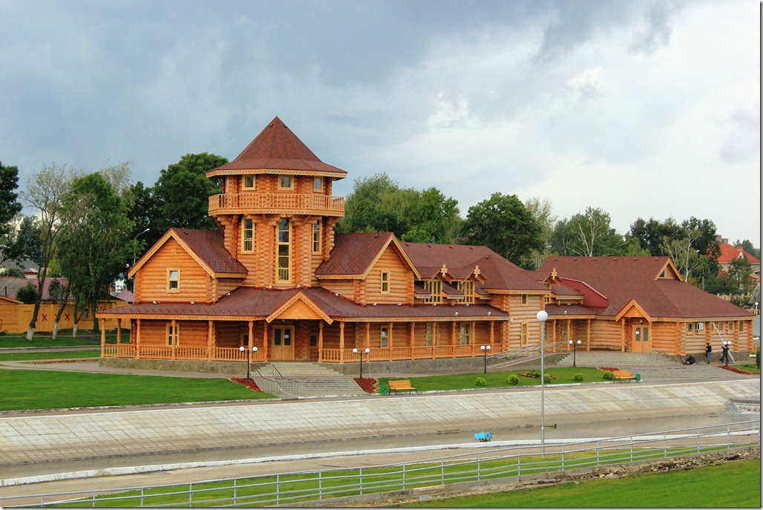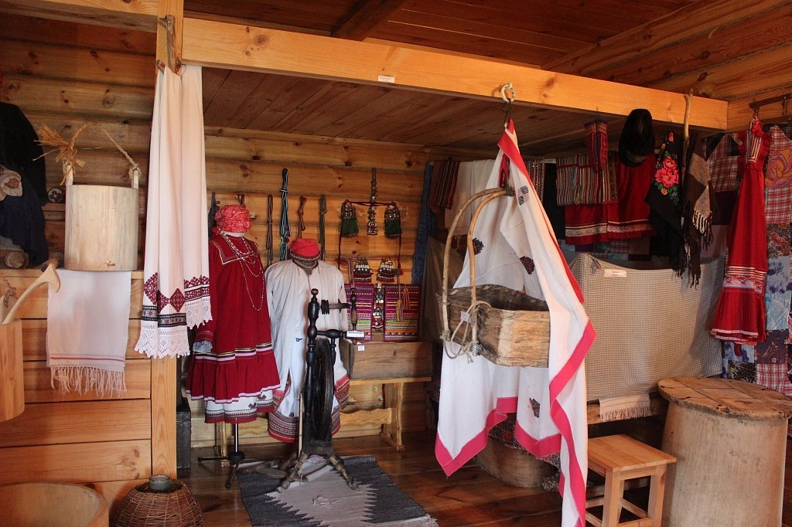

Тема для обсуждения:
“Mordovia is the place where I was born”

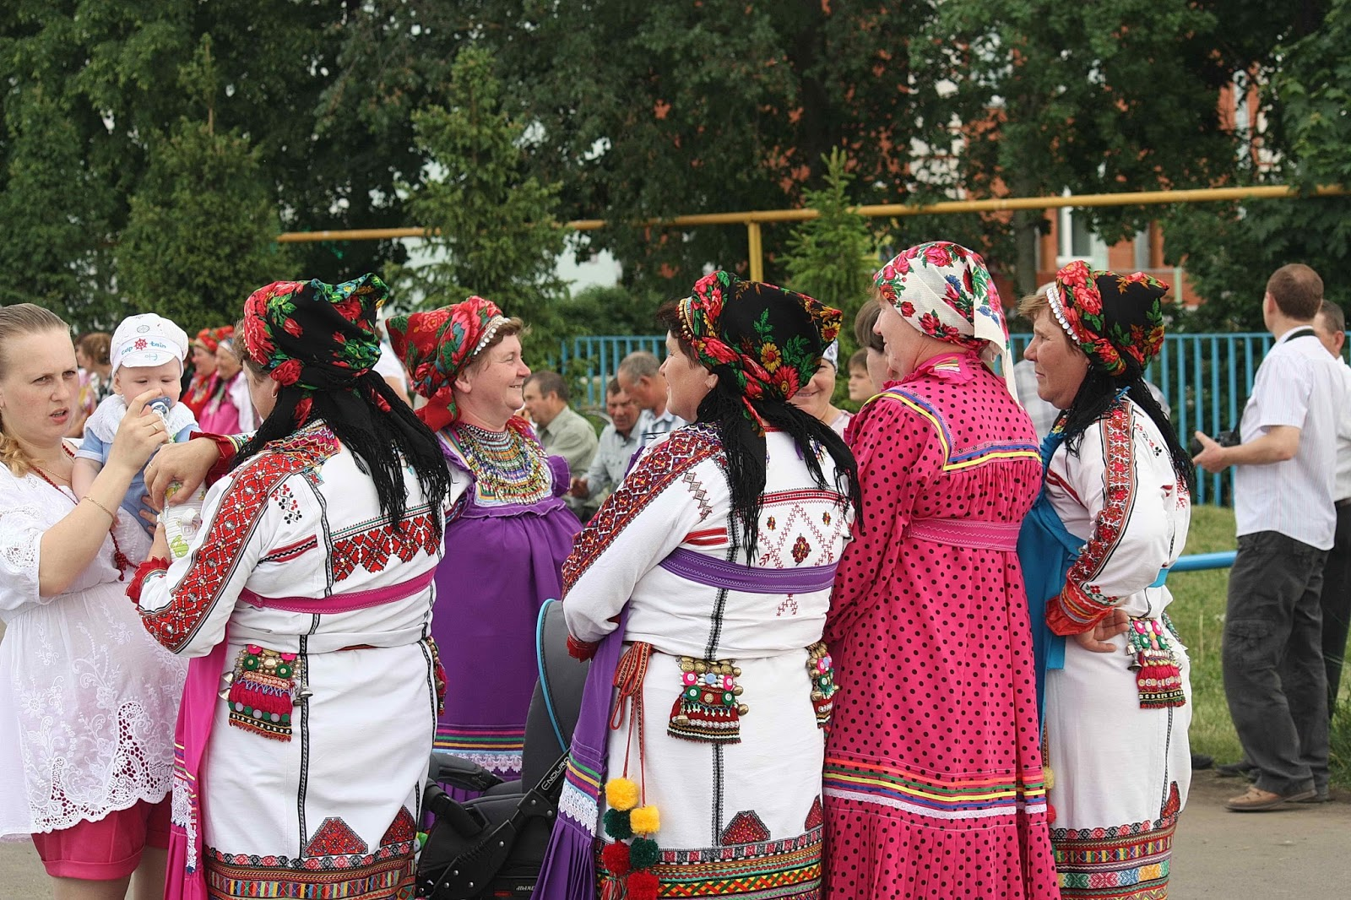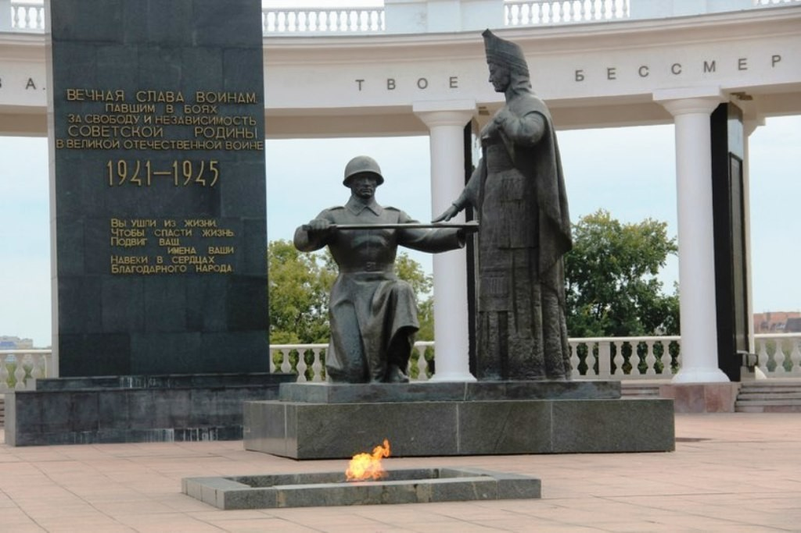

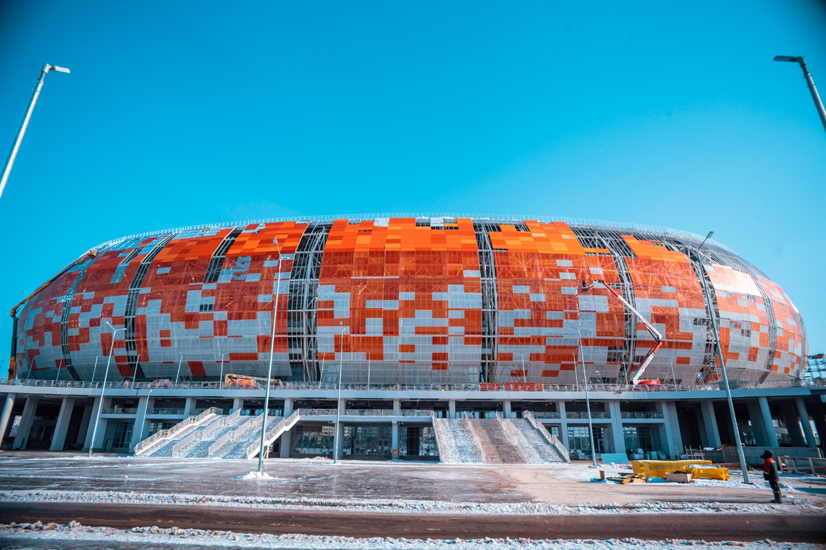

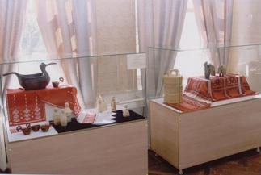

Аннотация

Современная система образования направлена не только на передачу определенного набора знаний, умений и навыков, но и на интеллектуальное и нравственное развитие личности. Основные цели данной работы – формирование креативного и критического мышления, умения оперировать полученной информацией и применять знания на практике в различных ситуациях. Расширить кругозор знаний о своем родном крае, воспитывать чувство патриотизма, любовь и уважение к традициям и достижениям своей Родины. Данная работа дает возможность учащимся размышлять, самостоятельно искать, анализировать, обобщать, обрабатывать необходимую информацию. Учащиеся переносят полученные ранее знания, умения, навыки в новую ситуацию, развивая навыки чтения с полным пониманием текста, диалогическую речь, аудирование, демонстрируют грамматические знания. Учащиеся сопоставляют различные точки зрения, объясняют и отстаивают свое мнение, опираясь на статистические факты, на свой и чужой опыт. Проектная деятельность помогает воспитывать в учащихся толерантное отношение к собеседникам, учит слушать и слышать, а также взаимодействовать друг с другом.
Проект включает в себя сведения о Мордовии, о столице и ее достопримечательностях. Для учащихся предлагаются следующие виды деятельности: чтение с полным пониманием текста, поисковое чтение, монологическая речь. Работа рассчитана для учащихся 7-9 классов.

Territory and economic.
The Republic of Mordovia is located in the centre of European part of Russia in the Volga basin. Total occupied area is 26.2 thousand sq. km. The Republic stretches from west to east for about 280 km and from north to south for 55 to 140 km. It borders the Nizhny Novgorod region in the north, the Ulyanovsk region in the east, the Penza region in the south, the Ryazan region in the west and Chuvash Republic in the northeast.
The Republic is divided into 22 administrative districts. There are 7 towns within its territory, among them Saransk, Ruzaevka, Kovylkino are under republican subordination and Ardatov, Insar, Krasnoslobodsk, Temnikov are under district subordination. The capital of the Republic is Saransk with population of 336 000 people (2003) which is situated 600 km away from Moscow.
The Constitution of the Republic of Mordovia was adopted on the 21st September 1995.
The population of Mordovia has been estimated at 899.6 thousand people as on 1st January 2003. Mordovia is a multinational republic. Mordva, Russians, Tatars, Belorussians, Ukrainians, Udmurts, Armenians and other nations live on its territory. The Republic of Mordovia is one of the densely populated areas in the centre of Russia. The population density is five times higher than all over Russia on the average.
The dominating religion of the Republic population is Orthodox Christianity. The state national official languages are Russian and Mordovian (moksha, erzia). The Mordovian language belongs to Finno-Ugric group of Ural-Altay language family.
The region is a part of the Volga-Vyatka economic region. The main industrial centers are Saransk and Ruzaevka. Mordovia is located at the joint of forest and steppe natural zones therefore its landscape is extremely different including dark forests, forest-steppe, black fertile lands and traces of Middle Russian highland, marshes and sands, rivers and lakes, chalk mountains and smooth contours of black fertile areas. There are hot summer days and freezing winter frosts. There are more than 200 species of birds and about 60 species of mammals.
Agro-climatic resources of Mordovia are rather favourable for development of many branches of agriculture. Hot temperature is sufficient for planting winter rye, spring and winter wheat, barley, potatoes, hemp, forage crops.
Stable political climate in Mordovia enables growth of economic potential.
Sightseeing of Mordovia
If you’d like to see the national costumes of the Mordovians, old agricultural tools, wooden sculptures, as well as to learn about the rites and customs of the inhabitants, you can find it in the Museum of Mordovia Folk Culture.
The cultural life of the city is diverse and rich. Visit the Yaushev State Musical Theater and the Russian Drama Theater. The Memorial Museum of the Military and Labor Feat of 1941-1945 has exhibits dedicated to the second World War.
Residents of Saransk often visit the park named after the Russian poet Alexander Pushkin. The city garden appeared at this place in 19th century. At that time the garden area occupied only 2 hectares, but today it has 40 hectares. There are amusement rides, as well as a station for renting boats and catamarans on the bank of the river.
The open –area ethnographic museum complex was opened in 2012. “Mordovskoye Podvorye” contains a village house and courtyard buildings, typical of Mordovia. Employees of the complex demonstrate traditional national rites for the quests, tell visitors about pre-Christians beliefs of the Erzya and the Moksha. For example, a long time ago, Mordovia worshiped female deities, the Mother of the Forest, the Mother of the Earst, the Mother of the Wind, and others.
To really feel Mordovian culture, one needs to go to rural areas. For example, in the village of Staraya Terizmorga (70 km from Saransk). Here the traditional life of the Mordovian peoples is recreated in detail: local residents wear traditional clothes and conduct national ceremonies for everyone. Guests of the “House of the Richest Peasant”, an ethnographic complex, will see the peculiarities of the traditional of life and will be invited to try pancakes and drink beetroot poza.

Задания для работы над темой.
1.Read and answer the following questions:
1. What is the population of the Republic?
2. When was the constitution of the Republic adopted?
3. Do you know any famous people of the Republic of Mordovia?
4. What are the official languages in the Republic?
5. What are the main industrial centers of the Republic.
2.Match the names with the definitions.
1. It has exhibits dedicated to the second World War.
2. If you’d like to see the national costumes of the Mordovians, old agricultural tools, wooden sculptures you can find it there.
3. There are amusement rides , as well as a station for renting boats and catamarans on the bank of the river.
4. Here the traditional life of the Mordovian peoples is recreated in detail: local residents wear traditional clothes and conduct national ceremonies for everyone.
5.It contains a village house and courtyard buildings, typical of Mordovia.
6. It has an ethnographic complex, will see the peculiarities of the traditional of life and will be invited to try pancakes and drink beetroot poza.
3. True or False.
1. Agro-climatic resources of Mordovia are rather favourable for development of many branches of industry.
2. Mordovia is a one national republic.
3.There are more than 200 species of birds and about 60 species of mammals.
4. The Mordovian language belongs to Romano-German group of Ural-Altay language family.
5. The state national official languages are Russian and Mordovian (moksha, erzia).
6. The Republic is divided into 30 administrative districts.
7. It borders the Nizhny Novgorod region in the north, the Ulyanovsk region in the east, the Penza region in the south, the Ryazan region in the west and Chuvash Republic in the northeast.
8. The Republic of Mordovia hasn’t own Constitution.

4. You are guide. Give some information about the Republic of Mordovia or say about some places of interesting.

Анкета

ФИО (полностью) | Савинова Марина Николаевна
Место работы. Должность | МБОУ «Белозерьевская СОШ», учитель английского языка
Название статьи (полностью) | Моя Мордовия
Номинация | Общие сведения о республике Мордовия
E- mail | sawinowa.marina2015@yandex.ru

