Занятие кружка «Счастливый английский»
Руководитель: Дворецкова Т.А.
Реализовать 06.04.- 07.04. 2020г.
Сделанное задание cфотографировать и отправить на WhatsApp
Teacher: (учитель)Today our lesson is devoted to the personality of ourselves. Each person is unique. There are no two people alike. Each of you has his own individuality. Let’s start with the song ’’Proud of me”.
Children(дети поют песенку)
I am very proud of me,
I think I will sing out loud of me,
There ought to be a crowd of me
Because I am so special.
Yes, I do have pride in me,
I love ev'ry bright blue side of me,
I feel so satisfied in me
Because I am so special.
P-R-I-D-E spells pride,
That is P-R-I-D-E.
Pride is the feeling of feeling good about me,
About me.
Yes, indeed, I please myself,
My fingers, my toes, my knees, myself,
I hug and kiss and squeeze myself,
Because I am so special.
I seldom have a doubt of me,
I love ev'ry in and out of me,
I think I have to shout of me,
Because I am so very, very, very, very proud
Of me!
Практическое задание.
Children(дети заполняют карточку- анкету про себя)
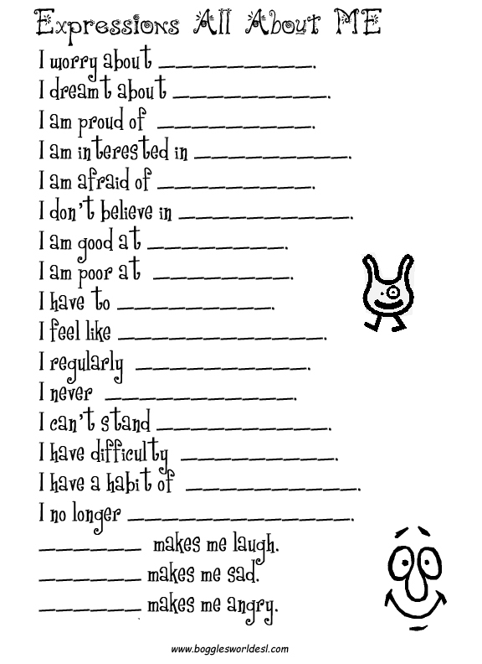
My full name: ___________________________________________
My nickname: ___________________________________________
If I could be named after a flower, my name would be ____________
If I could be named after anything, my name would be ____________
I was born on ____________________________________________
My eyes are ______________________________________________
My hair is ________________________________________________
I like ____________________________________________________
I don’t like _______________________________________________
I have ______brothers and _______sisters.
My favorite color is ________________________________________
My favorite food is ________________________________________
I have a best friend named __________________________________
My pets are ______________________________________________
My favorite animals are _____________________________________
My favorite subjects are ___________________________________
I go to school _____________________________________________
I use my ____________ hand for writing
My favorite book is ________________________________________
In my spare time I like to ____________________________________
A person I admire the most is ______________________________

Teacher:
And now let’s speak about your friends.
(ребята составляют о своих друзьях по той информации, которую только что услышали).
Прочитать и перевести:
Now, will you recite some poems about yourselves.
I'm Glad I'm Me
No one looks
The way I do.
I have noticed
That it's true.
No one walks the way I walk.
No one talks the way I talk.
No one plays the way I play.
No one says the things I say.
I am special.
I am me.
There's no one else
I'd rather be!

I am special. I am special.
If you look, you will see
Someone very special
Someone very special
That is me. That is me.

I HAVE SO MANY PARTS TO ME
I have two hands to clap with (clap)
One nose with which to smell (sniff)
I have one head to think with (tap head)
Two lungs that work quite well (take a deep breath)
I have two eyes that let me see (point to eyes)
I have two legs that walk (walk in place)
I have two ears that help me hear (cup hands to ears)
A mouth with which to talk. (point to mouth)

TEN LITTLE FINGERS
I have ten little fingers (hold up both hands)
And they all belong to ME (point to self)
I can make them do things
Would you like to see? (point to child)
I can shut them up tight (make fist)
I can open them up wide (open fingers)
I can clap them together and make them hide (clap, then hide)
I can jump them up high, I can jump them down low (over head and down)
And fold them together and hold them just so. (fold in lap)

That is me. That is me.
Here is my picture for everyone to see
No one else looks exactly like me
My hair, my eyes are different you see
My smile, my laughter are special to me
My nose, my mouth, hands and feet
make my features quite unique
So when you look upon my faceand see my "Angelshine"
You will know that I am specialbecause it’s all mine.

I am SPECIAL, I am ME. (point to self proudly with both thumbs)
I am special as I can be
because no one looks or acts like me.
I am one person, myself, me
and that's the way that it should be.
I Am Special
I am special, I am special.
God made me, God made me.
I am special, I am special.
So are you, so are you.
You are You
You are you and
I am me
There's nothing else
That we can be.
I have a little body
I have a little body
That belongs to me
I have two ears to hear with
And two eyes to see
I have a nose for smelling
And a mouth to eat
I have two hands to wave at
Everyone that I meet.

Прочитать и выучить стихотворения:

Why Am I?
Why am I so skinny and small?
Why aren`t I like you so medium and tall?
Why aren`t I as old as you,or as bold as you?
Why aren`t I like my friends, to the very end?
I hate being oh little me, for I am nearly as small as a bee.

Color Me Happy!
If I were the color blue,
I'd sing sad songs for you.
If I were the color yellow,
I'd be a happy fellow.
If I were the color red
I'd look like me when I bled.
If I were the color green,
I'd grow like a big string bean.
If I were the color brown,
I'd be a chocolate town.
If I were the color pink,
I'd be a lemony drink.
If I were the color purple,
Nothing would rhyme with me.
Teacher:
Families come in all shapes and sizes. It’s doesn’t matter what size and shape your family is. But families play a very important role in our lives. What are your roles in your families?
Children:
Son, daughter, grandson, granddaughter, brother, sister.
Teacher:
How do you help your family?
And now answer the question :Who are we?
Ребята заполняют рисунок-схему.

Практическое задание.
- Заполнить рисунок-схему соответствующими словами.
- Раскрасить рисунок.
