[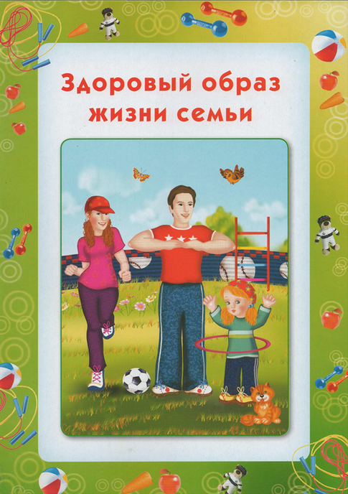](http://ds-scazkaviborg.jimdo.com/%D0%B7%D0%B4%D0%BE%D1%80%D0%BE%D0%B2%D1%8B%D0%B5-%D0%B4%D0%B5%D1%82%D0%B8-%D0%B2-%D0%B7%D0%B4%D0%BE%D1%80%D0%BE%D0%B2%D0%BE%D0%B9-%D1%81%D0%B5%D0%BC%D1%8C%D0%B5/)

[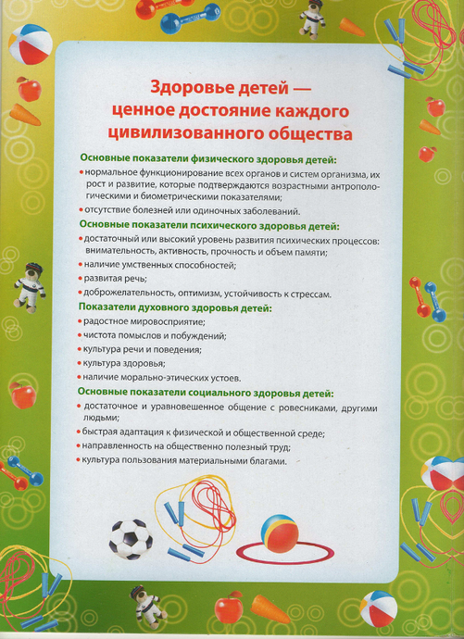](http://ds-scazkaviborg.jimdo.com/%D0%B7%D0%B4%D0%BE%D1%80%D0%BE%D0%B2%D1%8B%D0%B5-%D0%B4%D0%B5%D1%82%D0%B8-%D0%B2-%D0%B7%D0%B4%D0%BE%D1%80%D0%BE%D0%B2%D0%BE%D0%B9-%D1%81%D0%B5%D0%BC%D1%8C%D0%B5/)

[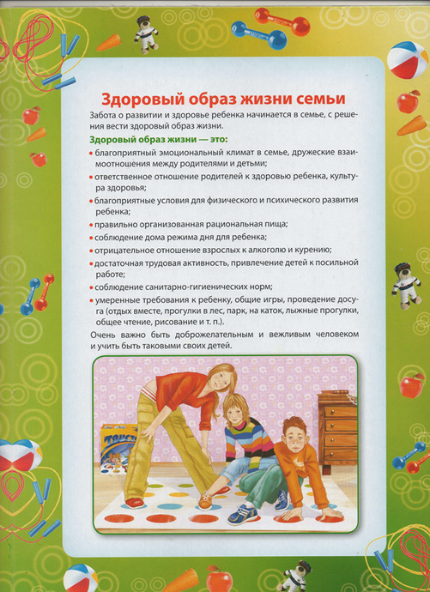](http://ds-scazkaviborg.jimdo.com/%D0%B7%D0%B4%D0%BE%D1%80%D0%BE%D0%B2%D1%8B%D0%B5-%D0%B4%D0%B5%D1%82%D0%B8-%D0%B2-%D0%B7%D0%B4%D0%BE%D1%80%D0%BE%D0%B2%D0%BE%D0%B9-%D1%81%D0%B5%D0%BC%D1%8C%D0%B5/)

[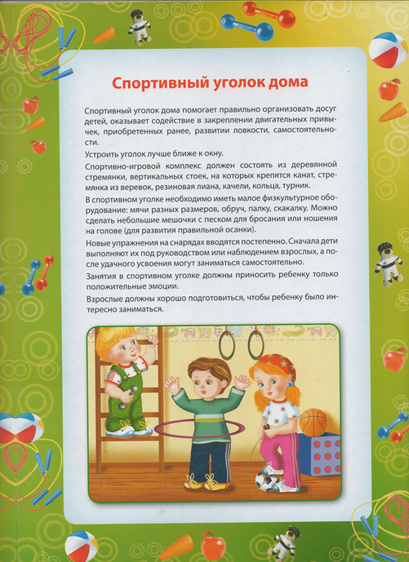](http://ds-scazkaviborg.jimdo.com/%D0%B7%D0%B4%D0%BE%D1%80%D0%BE%D0%B2%D1%8B%D0%B5-%D0%B4%D0%B5%D1%82%D0%B8-%D0%B2-%D0%B7%D0%B4%D0%BE%D1%80%D0%BE%D0%B2%D0%BE%D0%B9-%D1%81%D0%B5%D0%BC%D1%8C%D0%B5/)

[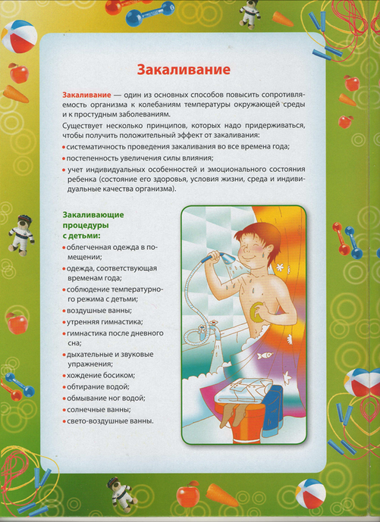](http://ds-scazkaviborg.jimdo.com/%D0%B7%D0%B4%D0%BE%D1%80%D0%BE%D0%B2%D1%8B%D0%B5-%D0%B4%D0%B5%D1%82%D0%B8-%D0%B2-%D0%B7%D0%B4%D0%BE%D1%80%D0%BE%D0%B2%D0%BE%D0%B9-%D1%81%D0%B5%D0%BC%D1%8C%D0%B5/)