[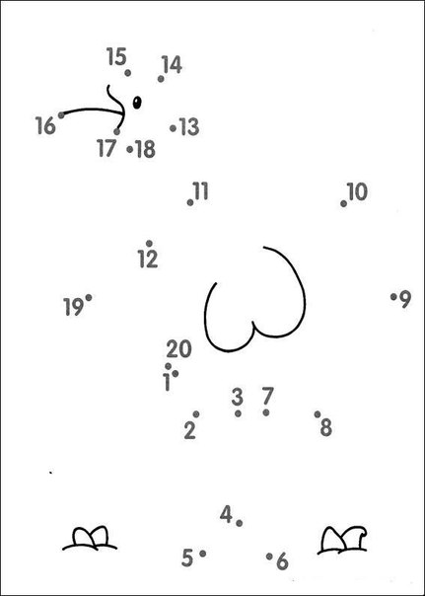](https://vk.com/photo-55615958_420874554)

[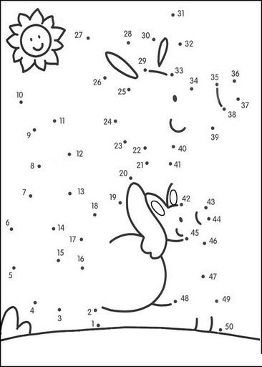](https://vk.com/photo-55615958_420874552)

[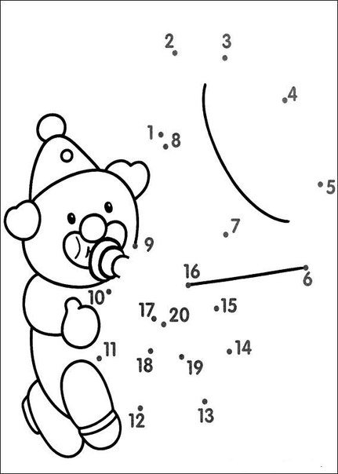](https://vk.com/photo-55615958_420874564)

[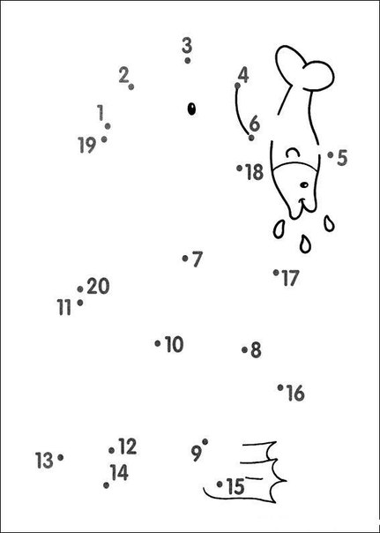](https://vk.com/photo-55615958_420874645)

[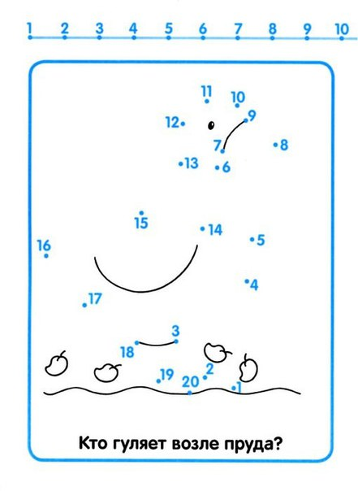](https://vk.com/photo-55615958_420874772)

[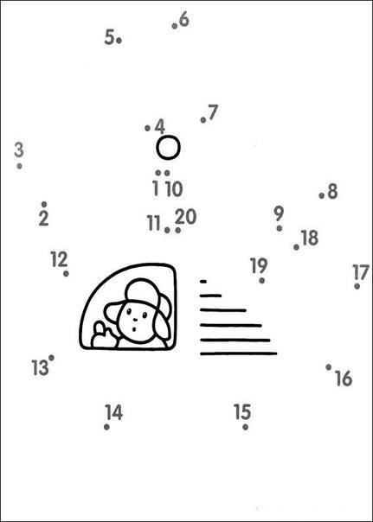](https://vk.com/photo-55615958_420874654)