Ликинова О.А.
Открытый урок английского языка в 6 классе по теме “Welcome to London”

Тип урока: урок обобщения и систематизации знаний по теме
Цели:
- Формирование коммуникативных способностей;
- Активизация познавательного процесса коммуникации на английском языке;
- Совершенствование речевой деятельности учащихся с использованием жизненно- важной современной информации.
Задачи:
Образовательные: совершенствовать лексические навыки по теме: “Лондон” на уровне свободного высказывания в виде монологической и диалогической речи, развитие навыков аудирования и чтения с извлечением необходимой информации.
Развивающие: развивать способности осуществлять продуктивные речевые действия
Воспитательные: прививать учащимся уважение и интерес к иноязычной культуре, воспитывать культуру общения.
Оборудование: иллюстрации достопримечательностей Лондона, раздаточный материал с лексическими единицами, учебно-наглядные пособия, интерактивная доска.
- Организационный момент
- Good morning, children!
- Good morning, teacher!
- I’m glad to see you, sit down, please! How are you today? Who is absent today? What date is it today?
- Фонетическая зарядка
Look at the screen. It’s a nice English proverb. I read it first and you repeat after me. (Интерактивная доска)

It’s better to see something once than to hear about it a hundred times.
Let’s translate it into Russian. Do you know Russian quivalent?

What is the theme of our lesson?
- Речевая зарядка.
Look at the screen. Guess what is it?
Угадываем достопримечательности по картинкам. (Интерактивная доска)
- Формируем цель и задачи уроков.
Дети формируют цели и задачи урока.
- Монологическая речь.
So, today we are going to London. We are at the airport. Attention. Take your seats, please. Fasten your seatbealts. The plane is taking off.
Here we are at last! Welcome to London, ladies and gentlemen!
What sights would you like to visit first? Your hometask was to tell some interesting facts about sights of London.
Дети рассказывают о Лондоне.
- The Big Ben.
The world-known clock. Everyday about 500 tourists come to London to see the Big Ben. Built in 1858, it was named after an architect whose name was Ben (Benjamin). The interesting fact is that you are not allowed to get inside the Big Ben if you aren’t an Englishman.
- Piccadilly Circus.
The place is far from what is called “a circus”. It is a well-known meeting point of the city. It has become so popular, that is now considered to be a place to visit for all the tourists.
- London Eye.
It is one of the biggest observation wheels in the world. Its height is 135 meters. It has 32 cabins which symbolize 32 districts of London. It takes 30 minutes to make a full circle. But it is the view you will never forget. The cost is about £20.
- London National Gallery.
The gallery has more than 2000 works of world-known artists of XIII-XX centuries. You can spend the whole day there and it will not be enough. What is interesting, is that the gallery is free for everyone.
St. Paul’s Cathedral. It was built on the highest point of London 300 years ago. It is the London Bishop’s residence and is the most popular place of visit. The price of visit is £16.

- Тренировка орфографического навыка.
What else can you see in London?
(Интерактивная доска)
Strong wind has blown and all letters have mixed. Who helps me to unsrabble these words?
(Интерактивная доска)
- umesum (museum)
- numontme (monument)
- ritteha (theatre)
- distamu (stadium)
- legalry (gallery)
- aresqu (square)
- Работа в парах. Самоконтроль.
Учитель раздает карточки.
For description of objects we use construction “there is / these are”. Now I’ll give you cards where you should complete the sentences with “there is / these are”. You have 3 minutes.
- There________ a bank __________the library.
- There _______some cats _________ the roof of the restaurant.
- There _______ two cars __________the library.
- There _______ a cathedral in the city.
- There ______ a park ___________the hospital and school.

- Физкультминутка.
(Интерактивная доска)
Are you tired? Let`s go to St. James Park

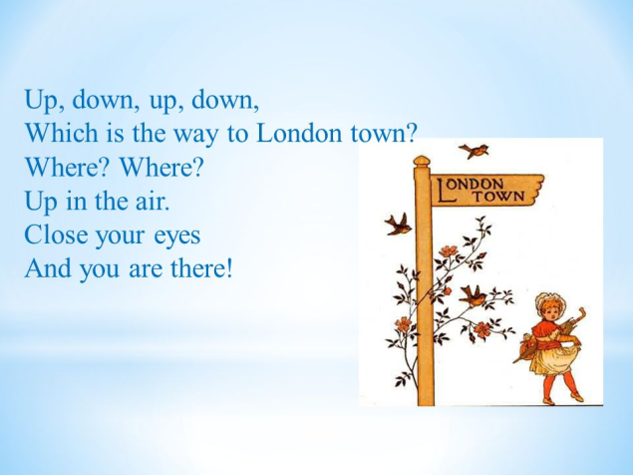

- Развитие навыков диалогической речи.
We have been walking in London so long, and we’d like to eat something delicious. Are you hungry? Let’s go to the nearest café.
(Интерактивная доска)
How can we order some food?
Open your books on page 81 and look at the dialogue. Listen and read.

- Работа в группах.
Now you are going to be divided into 3 groups. Each group of students will prepare their own presentation about sights of London. The first group about Parks and Squires, the second is about Museums and Theatres, the third – About The famous sights of London.
Учащиеся готовят плакаты с изображениями и описанием достопримечательностей Лондона.
The Big Ben is the world-known clock. it was named after an architect whose name was Ben (Benjamin).
London Eye is one of the biggest observation wheels in the world. Its height is 135 meters.
In 1894 Tower Bridge was opened across The longest and most famous river in the UK - The Thames.
Madam Tussaud's Museum is the most famous museum of waxworks. It presents all famous people from singers and actors to Prime Ministers and Presidents.
London National Gallery has more than 2000 works of world-known artists
At British Museum you can see some amazing mummies.
The Hyde Park is a traditional place of festivals and celebrations.
Piccadilly Circus is a well-known meeting point of the city.
In the middle of Trafalgar square you can see a statue of Admiral Nelson. its height is over 50 metres.

- Рефлексия.
Now I want you to evaluate your work at the lesson. If you think you work well, show me “Big Ben”. If you are not satisfied with your work, show me “Double-decker bus”.

